**K. Aparna**

**Task -2**

**Task Description:** To set up a Virtual Private Cloud (VPC)/ Vnet on Azure/AWS cloud to securely host your resources, allowing you to define your own network environment.

**Step 1:** I Log in to the AWS management console with my credentials.

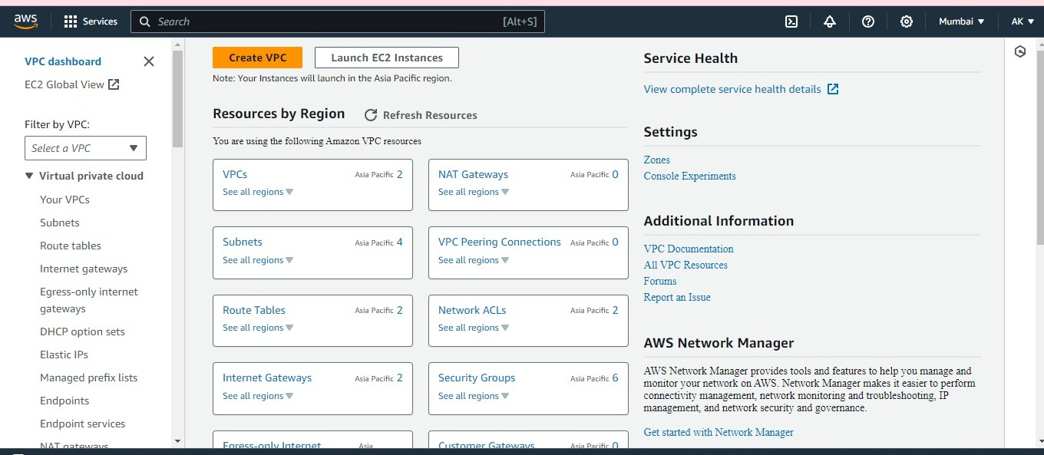

**Step 2:** Open VPC dashboard and click on “Create VPC”.

Enter details such as

* Name :my_vpc_1
* IPv4 CIDR block :10.0.0.0/24
* Key value : Name : my_vpc_1

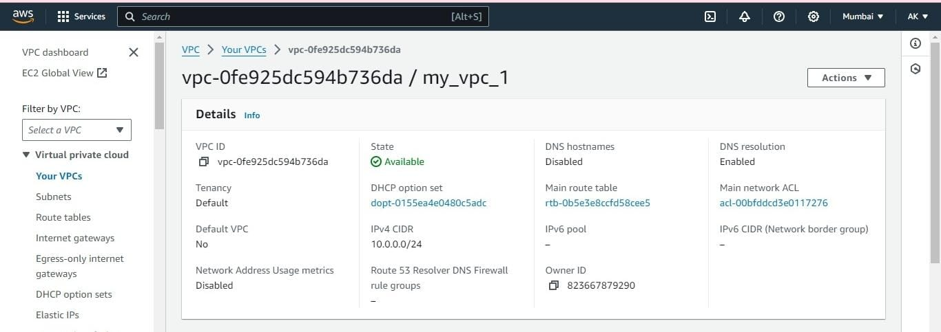

**Step 3:** Within VPC, create subnets in different availability zones and specify CIDR block for each subnet.

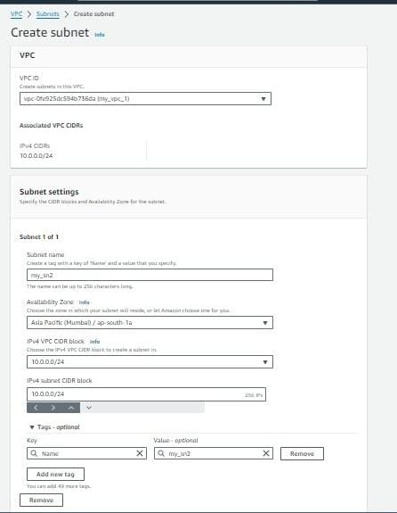

**Step 4:** Define route tables for your subnets to control traffic flow within the VPC.

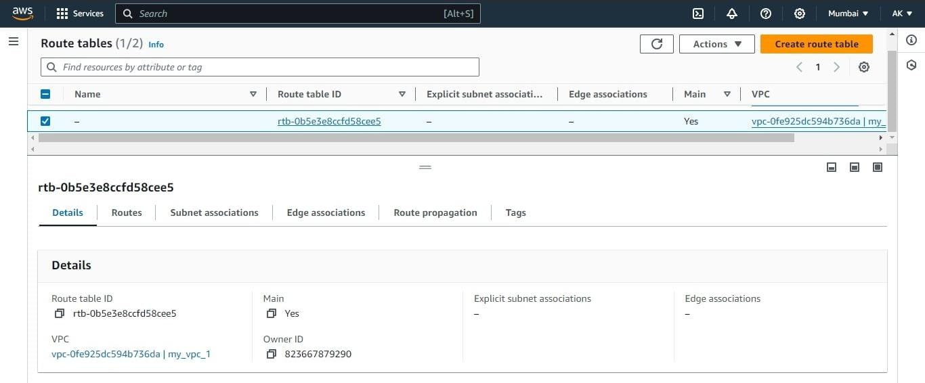

**Step 5:** Now specify routes to internet gateways. Create internet gateway and attached to my VPC.

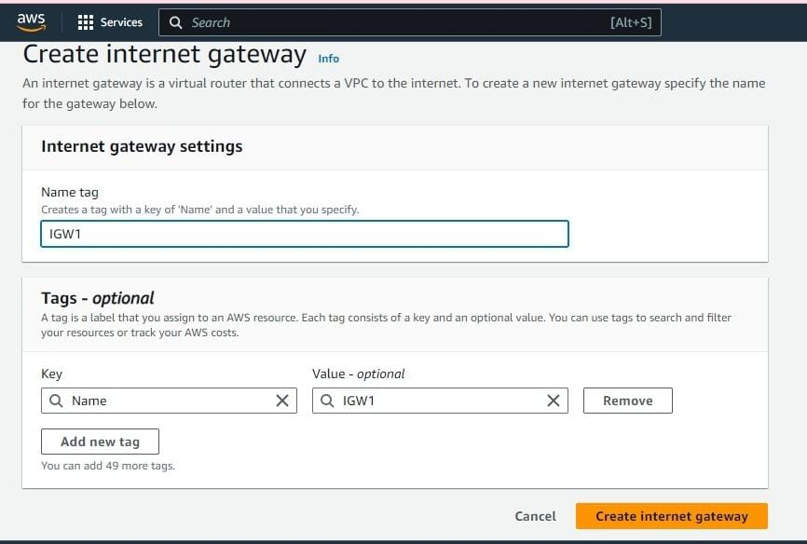

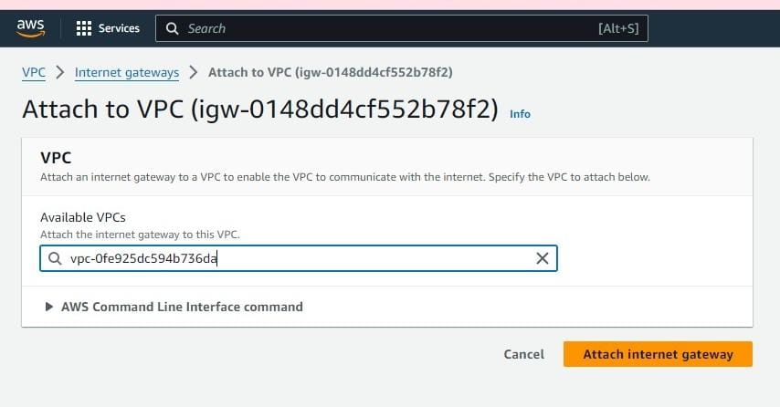

The creation of a VPC with associated components in AWS provides a secure, scalable, and customizable network environment for hosting your cloud resources, ensuring they operate within a controlled and protected network perimeter.